Imagine School at Town Center wishes to thank the following:

**Our Entire ISTC Family for their support and encouragement! Thanks for your judging, your help, and your patience!!!**

**ISTC PTO for their support of our school and the donation of the science prizes for our students!**

Our Volunteers:

**Christina Moore Heather Speir**

**Geeta Patel Sandy Sylvester**

**Sara Radford Chris Pane**

**Majorie Green Scott Knight**

**Kelly Castellano Daniele & Wagner de Freitas**

and all of the parent donations…Thank You!

Plan to join us at the Southeast Group Science Fair:

*Kissimmee Civic Center 201 East Dakin Avenue Kissimmee, FL 34741 407-935-1412*

***Tuesday, January 23, 2018***

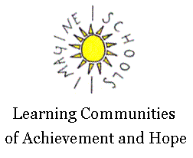

Imagine School at Town Center

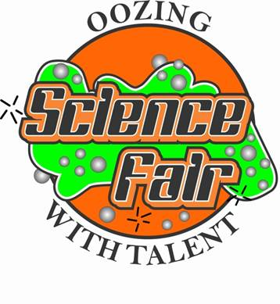

2017 Science Fair

**4th Grade - Teachers: Darla Beck, Kathleen Crock, Colleen Fonte, & Joshua Hoppock,**

|  |  |
| --- | --- |
| **BIOCHEMISTRY**  Sydney Allen - 1st  Taylor Sylvester - 2nd  Kaylin Brennan – 3rd  Aasi Bharucha - HM | **BOTANY**  Katie Rooney - 1st  Sienna Van Baelen - 2nd  Jessalynne Yaple - 3rd |
| **CHEMISTRY**  Cannon Garvin - 1st  Sophia Posella - 2nd  Lucas Veloso - 3rd  Isabella Watson - HM | **PHYSICS**  Kyler Wilson - 1st  Lucas Cassady - 2nd  Makayla O’Neal - HM  Syed Haider - HM |
| **MATH & COMPUTER SCIENCE**  Chetanroop Patel - 1st | **BEHAVORAL & SOCIAL SCIENCE**  Margaret Magnell - 1st |
|  | **MEDICINE & HEALTH**  Abigail Luckett-Ryman 1st  Gabby Roman - 2nd  Alyssa Gomom - 3rd |

**5th Grade – Science Teachers: Nanette Lamb & Skyla Thorpe**

|  |  |
| --- | --- |
| **BEHAVIOR & SOCIAL SCIENCE**  Chloe Wallace - 1st  Lilyth Walker - 2nd | **ENGINEERING**  Anabelle Moore - 1st  Anjalie Tomerlin - 2nd |
| **CHEMISTRY**  Jordan Draugelat - 1st  Frankie Kingsley – 2nd  Ryan Tomczak – 2nd  Kayden Wheat – 3rd  Marissa Emden - HM  Ythan Fernandez - HM  Nicholas Joseph - HM  Marly Harrelson - HM  Keary Lewis - HM  David Purdy - HM  Mia Tsouklaris - HM  Evangeline Viera –HM | **PHYSICS**  Jasper Donoso – 1st  David Nickel – 2nd  Everson Dailey – 3rd  Nicholas Adams - HM  Gabriela Barros - HM |
| **BIOCHEMISTRY**  Cayla Sobin - 1st  Rae Anthony Lewis - 2nd  Hailey Giacobbe - 3rd | **BOTANY**  Maria Sadio - 1st  Damari Jackson - 2nd  Shakhzod Ismailov - 3rd |
| **EARTH, SPACE, & ENVIRONMENTAL**  Colin Murray - 1st  Candace Cobb - 2nd | **MEDICINE & HEALTH**  Xamuel Bressler - 1st  Mila Mckee – 2nd |

**Middle School – Science Teachers:** **Jessica Bowman (6th), Darlene Benjamin (7th) & Kristin Wilkinson (8th)**

|  |  |
| --- | --- |
| **BEHAVIOR & SOCIAL SCIENCE**  Lily Puritis - 1st  Sophia Mikos - 2nd  Emmeline Mester – 2nd  Alex Little - 3rd  Miranda Confer **-** HM  Julie Dias – HM  Kylee Fleenor – HM  Kaitlyn Gennaro - HM | **ENGINEERING**  Jeremiah Donoso – 1st  Priya Tomerlin – 2nd  Ethan VanBaelen – 3rd  Ricardo Veloso - HM |
| **EARTH, SPACE, & ENVIRONMENTAL**  Jared Foley – 1st  Haley Luckett-Ryman – 2nd  Micah Wilson - 3rd  Gabriel Moyer - HM | **MATH & COMPUTER SCIENCE**  Prathna Patel - 1st  Naomi Knight - 2nd  Amelia Saunders- 3rd |
| **BOTANY**  Mason Stadler – 1st  Michelle Marinez – 2nd | **BIOLOGY**  Tiffany Pane - 1st  Gracielou Weed - 2nd |
| **BIOCHEMISTRY**  Grace Norris – 1st  Alexandra Khoriakov – 2nd  Aubrey Overton – 2nd  Brayden Sohl – 3rd | **CHEMISTRY**  Hunter Allen – 1st  Lilly Zavyalov – 2nd  Emmy Caskin - 3rd  Arwen Frye - HM |
| **MEDICINE & HEALTH**  Liza Guseva 1st  Nicholas Biancaniello 2nd  Isaac Trawick 3rd  Michael Silva HM  Paige Radford HM | **PHYSICS**  Savannah O’Grady – 1st  Izac Derequito – 2nd  Troy Tallaksen -3rd  Jake Morris - HM  Ta’Kiyah Souvenir - HM |