Student Name ___________________________________ Class _______

2019-2020
4th & 5th Grades
ISTC SCIENCE FAIR MINI PACKET
Due Dates

Acknowledgment Form Fri, 10/18/19

Parent Info Night Tues, 10/22/19 6:30 pm – school cafeteria (geared for 1st timers and 4th Grade)

Documentation Form Fri, 11/1/19

Bibliography Typed Fri, 11/15/19

Presentations Begin Mon, 12/2/19

ISTC School Science Fair Tuesday, 12/17/19 school cafeteria .

Regional Science Fair Thursday, 1/23/20 Kissimmee, FL .

CATEGORY DESCRIPTIONS

Projects will be assigned to one of the following ten categories based on the problem solved, research, and application.

Behavioral and Social Sciences*: Human and animal behavior, social and community relationship – psychology, sociology, anthropology, archaeology, learning, perception, urban problems, public opinion surveys, educational testing, etc.
Biochemistry*: The chemistry of life processes – molecular biology, molecular genetics, enzymes, photosynthesis, blood chemistry, protein chemistry, food chemistry, metabolism, and hormones.

Biology (including Microbiology and Zoology): The study of the anatomy, physiology, and processes of living things - bacteriology, virology, protozoology, fungi, yeast, animal development, pathology, physiology, systematics.
REMEMBER: You can’t display micro-organisms, someone may be allergic to them!

Botany: The study of plant life – agriculture, agronomy, horticulture, forestry, plant taxonomy, plant physiology, plant pathology, plant genetics, hydroponics, algae, etc.

Chemistry: The study of the nature & composition of matter, and the laws governing it – physical chemistry, organic chemistry, inorganic chemistry, materials, plastics, fuels, pesticides, metallurgy, soil chemistry, etc.
You may test some consumer products here.
Earth, Space & Environmental Sciences:
(Earth Science) The Study of Earth’s structure and processes. - geology, mineralogy, physical oceanography, meteorology, seismology, geography, topography.
(Space Science) – astronomy, star visibility, astrological computations
You can’t test planets, star, or the moon – no solar systems please.
(Environmental Science) – The study of interactions among physical, chemical, and biological components of the environment – air, water, and land pollution sources and their control, ecology, waste disposal, impact studies, etc.
Engineering: Technology projects that directly apply scientific principles to manufacturing and practical uses – civil, mechanical, aeronautical, chemical, electrical, photographic, sound, automotive, marine, heating and refrigeration, transportation, etc.

Math and Computer Science: Probability, statistics, applied math and analysis, artificial intelligence, algorithms, databases, programming languages, operating systems, networking, computer graphics, etc.

Medicine and Health*: The study of diseases and health of humans and animals – medicine, dentistry, pharmacology, pathology, veterinary medicine, nutrition, sanitations, pediatrics, allergies, speech and hearing, etc.

Physics: The study of matter, energy, and forces – states of matter, thermal energy, chemical energy, radiant energy, electricity, sound waves, light waves, conductors, insulators, gravity, magnetism, forces, simple machines, friction, etc.
*BE CAREFUL: When working with humans or animals you must get PRIOR approval from your teacher.
NO HUMANS OR ANIMALS MAY BE HURT DURING THE PROJECT

DATA NOTEBOOK GUIDELINES
A data notebook is mandatory for all grades (4th through 8th).

When you do an experiment, you make observations. You may record changes in your subjects, make notes about possible influences in your experiment that you didn’t anticipate, or draw pictures of results along the way. All scientists are constantly recording relevant observations. Graphs, charts or tables should represent the data properly (preferably with metric units if applicable). A data notebook is a journal that may be set up to reflect observations by the week, day, hour or minute, depending on the type of experiment. You could organize it by putting a day’s observation on each page. A student’s data notebook should also contain any other notes he/she may have made from the research, such as article summaries, important phone numbers or even possible contacts. Entries should be neat, dated, and orderly. It should be a complete and accurate record of the student’s project from start to finish. The data notebook is both qualitative (observations with senses) and quantitative (numbers & measurements). It shows all the time and effort that went into the project. The data notebook may be typed or handwritten. Student name should be on the back of the notebook.
Suggestions: ½ inch binder, composition book, spiral notebook, or folder.
Day 2
January 21st
My dad said to spray the plants with an equal amount of bug spray. I will have to add this control to my list.
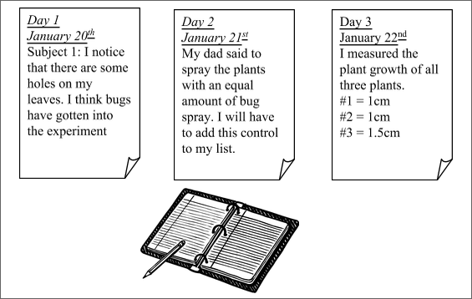

REPORT GUIDELINES

A typed report is not required for 4th or 5th grade students. However, some components needed for the display board are described in the report section.
A typed report is mandatory for all competing middle school students (grades 6 through 8).

The typed report is a formal presentation of the research, investigation, experimentation, and conclusions. It gives detailed information about the science project, and scientific methods. It may include pictures, diagrams and added knowledge the student has gained through reading or research, experimentation, or interviews.

The entire report should be typed (12-14 font), easy-to-read, double-spaced, and placed 3-ring binder or folder. The cover should state the project title and a graphic. It should not include the student’s name. Components of the report must be neat and in order.
ORAL PRESENTATION

Oral presentations are mandatory for all students (grades 4 – 8). The oral presentation is a short 3-5 minute oral presentation describing your project and experimental design. It is also a chance for you to answer questions and show the knowledge you have gained through research and experimentation. If you wish to add a prop or aid to your presentation, it must not take up more space than the board allows. It must be able to fit in the small space in front of the board. Feel free to use technology in your presentation. Just keep in mind that simply showing a slide show isn’t a presentation. You must do the presenting, but you can use technology as an aid. Please keep in mind that Wi-Fi is not always available.
Oral Presentation Tips
- It is perfectly natural to be nervous.
- Begin by introducing yourself and your project.
- Explain your project components. Refer to your board headings, or write brief notes on cards, but don’t read from them word for word.
- Use visuals, pictures, graphs, or props to help explain the details of your project.
- Explain your data and how you collected it.
- Make sure you use and pronounce the key terms mentioned in your project properly.
- Maintain eye contact.
- Speak clearly and slowly.
- Practice your presentation in front of family members, friends, or a mirror.
- When finished, ask the judge, “Do you have any questions?”
- If a judge asks you a question on something you do not know, don’t worry. Discuss what you do know.
Presentations begin 12/2/19
DISPLAY BOARD GUIDELINES

A 36 in X 48 in./the larger one), tri-fold display board is mandatory for all competitors at the school and region.

4th grade students: Students who compete at the school and region must have a display board with all components except an ABSTRACT SUMMARY. Students may include additional photos if desired.

5th grade students: Display boards are mandatory for all competing students. The board must contain all components except an ABSTRACT SUMMARY. Students will replace this section with a multi-paragraph RESEARCH SUMMARY. The summary should be a minimum of one typed page double-spaced. A bibliography of research sources (1 page minimum) should be attached to the back of the Abstract Summary for students who compete.

Middle school students (Grades 6-8): Display boards are mandatory for students who compete at the school, region, and state. The board is to contain all the components including an ABSTRACT SUMMARY.
The data notebook and written report are separate from the board and will be displayed in front of the board.

Photos: All photos must have a caption. Pictures should be of the outcome of the experiment with no faces.

Judging Criteria: The display board is judged based on grammar, creativity, the scientific method, thoroughness, and neatness. All items must be typed and placed in the correct location and order. Please don’t use staples.

The board is to contain all the components including an ABSTRACT SUMMARY.
Board size: A larger (36 in X 48 in.), tri-fold presentation board that can be purchased in an office supply, or local supermarket store. It must be freestanding and sturdy. First impressions can make a difference. Be creative.

Judging Criteria: The display board is judged based on grammar, creativity, the scientific method, thoroughness, and neatness. All items must be typed and placed in the correct location and order. Please don’t use staples.
DISPLAY BOARD FORMAT
All items must be typed and placed in the correct location and order with titles. Wording can be larger than 12-14 font and does not need to be double-spaced. Student names should not be written on the front of the board. Please put name on the back of the board.
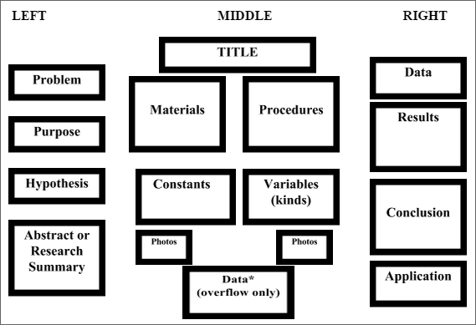
STUDENT DOCUMENTATION FORM
(This must be turned into your teacher and approved before you begin the project.)

STUDENT:_________________________ HR Class:_________________ DUE: ____________
NO partners allowed in 4th or 5th Grades.

SUBJECT: (What topic do you want to research?) _________________________________________

PURPOSE: (Why you are doing the research and experiment?)
___________________________________________________________________________________

___________________________________________________________________________________

PROBLEM: (What question will you will investigate? It cannot be answered yes or no.)
___________________________________________________________________________________
____________________________________________________________________________________

HYPOTHESIS: (What you think is the answer to the question. You may change this after doing your research, but you may not change it after you begin your experiment.)
____________________________________________________________________________________
____________________________________________________________________________________

EXPERIMENT SUMMARY: (How and where will do you plan on testing your hypothesis?)
____________________________________________________________________________________
____________________________________________________________________________________
____________________________________________________________________________________

TIME NEEDED: (How long will you need to perform 3 trials?) _____________________________

MATERIALS: (What will you need to perform the experiment?)_______________________________
____________________________________________________________________________________
____________________________________________________________________________________
Approximate Cost of Project: ____________________ + Optional Competition Board/ Materials $10+
I plan on COMPETING or NOT COMPETING (circle one)

Parent Approval: _____________________________________ Date: __________________
Student Acknowledgement _____________________________
Teacher Approval: ____________________________________ Date:__________________

Teacher Comments:______________________________________________________________

PARENT/GUARDIAN ACKNOWLEDGEMENT FORM
(This must be turned in to your teacher before you begin the project.)

Student Name:_____________________________ Home Room :_______________

Dear Parents/Guardians & Students,

Please review the Imagine Schools Science Fair Student Mini Handbook and sign this document as acknowledgement that:

- You are aware the annual Imagine Schools Science Fair project and competition has begun.
- You are aware of the project timeline, components, due dates, and grading rubric.

- You are aware that a complete handbook is available on-line and should be used by those students who wish to compete.
- You are aware this is a long-term research and experimentation project done mostly at home.
- You are aware of that this project will impact your child’s grade.

- You are aware that presentations begin on Monday, 12/2/19.

_______________________________ ___________________
Parent/Guardian Signature Date

_______________________________ ___________________
Student Signature Date

Return to Science Teacher by: Friday, 10/18/19

