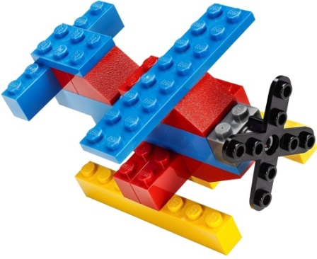
Imagine School at Town Center
Brick Builders Club
1st Grade & 2nd Grade
SESSION #3
Discover Design Create
Tuesdays – November 12, November 19,
December 3. December 10
Or
Thursdays -- November 14, November 21,
December 5. December 12
Time: 3:30 p.m. – 4:35 p.m. Location: STEAM Lab

Fee: $20 per student for 4 sessions with Mrs. Franklin or Ms. Demers

Student’s Name: _____________________________________ Grade: ___________
How will your student get home from club? Circle One
Teacher’s Name: __________________________
Parent’s Name: ___________________________ Car Rider # ______ Aftercare
Phone Number: ______________________ Email: ____________________________
There are only 20 slots for Brick Builders Club. Please circle either Tuesday or Thursday. Students will stay after school in the “club room” and be dismissed to STEAM lab. Pickup by front car rider, must have car rider #. Students in aftercare will be sent there.

I, ________________________________ give consent for my child, _______________________ to be photographed in Brick Builders Club. Pictures are posted on www.istcscience.weebly.com.
Parent Signature: _________________________________________________
Payments due by 11/12 /19. Checks payable to ISTC. Unpaid slots will be offered to next in line.
Teachers please return all registration forms to Mrs. Franklin or front desk

