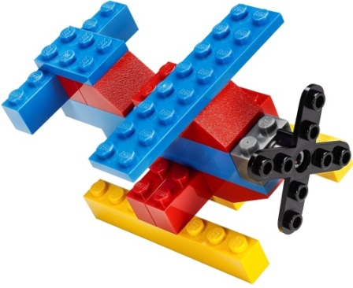
Imagine School at Town Center
Brick Builders Club
3rd & 4th Grade
Session 3
Discover Design Create

Fridays -- November 15, November 22,
December 6. December 13
Time: 3:30 p.m. – 4:30 p.m. Location: STEAM Lab

Fee: $20 per student for 4 club days with Mrs. Franklin or Ms. Demers

Student’s Name: _____________________________________ Grade: ___________
How will your student get home from club? Circle One
Teacher’s Name: __________________________
Parent’s Name: ___________________________ Car Rider # ______ Aftercare
Phone Number: ______________________ Email: ____________________________
There are only 20 slots for 3rd & 4th Grade Brick Builders Club. Students will stay after school in the “club room” and be dismissed to STEAM lab. Pickup by front car rider, must have car rider #. Students in aftercare will be sent there directly after.

I, ________________________________ give consent for my child, _______________________ to be photographed in Brick Builders Club. Pictures are posted on www.istcscience.weebly.com.

Parent Signature: _________________________________________________
Payments due by 11/15/ 19. Checks payable to ISTC. Unpaid slots will be offered to next in line.
Teachers please return all registration forms to Mrs. Franklin or front desk

