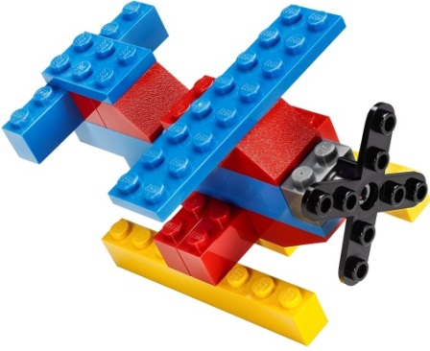
Imagine School at Town Center
Brick Builders &
STEAM Club
Kindergarten – Session 3
Discover * Design * Create
Optional Brick Builders Club t-shirt $12 each
May be worn as a spirit shirt!
_____YS ____YM _____YL _____YXL
_____S _____M ______L ______XL
Tuesdays – April 30th, May 7th,
May 14th, May 21st, May 28th

Time: 3:30 p.m. – 4:30 p.m. Location: STEAM Lab with Mrs. Franklin
Fee: $25 per student for 5 sessions, to benefit the STEAM lab
Registration Form
Student’s Name: _____________________________________ Grade: ___________
How will your student get home from club? Circle One
Teacher’s Name: __________________________
Parent’s Name: ___________________________ Car Rider # ______ Aftercare
Phone Number: ______________________ Email: ____________________________
Once we have received all registration forms, we will determine if a lottery is necessary. There are only 18 slots for Brick Builders Club. Forms due 4/16/19, payment due 4/22/19. Checks please, payable to ISTC. Unpaid slots will be offered to next in line.
If necessary, we will hold lottery drawing and notify you by Tuesday 4/18/19.

I, ________________________________ give consent for my child, _______________________ to be photographed in Brick Builders & STEAM Club. Pictures are posted on www.istcscience.weebly.com.

Parent Signature: _________________________________________________
Teachers please return all registration forms to Mrs. Franklin or Mrs. Puritis

