SCIENCE FAIR STUDENT HANDBOOK
2019-2020

Table of Contents

Science Fair Questions 1
Category Descriptions 3
Progression Plan 5
Data Notebook Guidelines 6
Report Guidelines 7
Report Components 8
Bibliography Guidelines 12
Display Board Guidelines 13
Display Board Format 14
Oral Presentation 15

APPENDIX
Resources
Helpful Websites

Forms
Parent Acknowledgement Form
Student Documentation Form
Bibliography Worksheet

SCIENCE FAIR QUESTIONS
WHAT IS A SCIENCE FAIR PROJECT?
A science fair project is a chance for the student to be the scientist and explore a subject of interest. It allows for self-directed exploration of the scientific process, application of scientific methods, develops research, writing, critical thinking, and language skills. It helps to stimulate curiosity, and encourages students to HAVE FUN while they are learning.
Science fair is a key instructional method to implement the Common Core, and the Next Generation Standards. The end result of science fair is problem-based inquiry style learning. This type of learning helps students refine valuable skills they need for the 21st century (such as critical thinking, collaboration, and communication).
All science fair projects contain five main components.
- Scientific Investigation & Research
- Expermimentation
- Critical Thinking
- Communication
- Applying Scientific Methods.

WHAT IS THE SCIENTIFIC METHOD?
The Scientific method is a procedure that scientists use to answer questions and solve problems. They are as follows:
- Ask a question
- Form a hypothesis
- Test the hypothesis
- Analyze the results
- Draw conclusions
- Communicate results

WHAT IS NOT A SCIENCE FAIR PROJECT?
A science project IS NOT a book report. Although you need to do research, you must test a hypothesis.
A science fair project IS NOT a demonstration. You will have the opportunity to demonstrate what you have learned, but you must have performed experiments and collected data.
A science fair project IS NOT building a model. You might construct models for your experiment, but you must be solving a problem.

HOW DO I GET STARTED?
Find a topic that interests you. Choosing a topic requires much thought. Try looking through journals and magazines like Natural History, Popular Mechanics, National Geographic, Consumer Reports, or Science News. The internet is also an excellent source of ideas and information. There is a list of a few internet sources in the appendix. Choose a topic that interests you and then decide how you can do an experiment that deals with this topic. Think how this project might improve the world and its inhabitants. Questioning is probably the most important part of scientific creativity. Questioning usually leads to experiments or observations. Choose a limited subject, ask a question, and identify or define a problem.

WHAT’S NEXT?
Decide what type of project suits your needs.
- A field (outdoors) investigation
- A laboratory (indoors) study
- A series of experiments or tests
- A carefully collected set of observations

CATEGORY DESCRIPTIONS

Projects will be assigned to one of the following ten categories based on the problem solved, research, and application.

Behavioral and Social Sciences*: Human and animal behavior, social and community relationship – psychology, sociology, anthropology, archaeology, learning, perception, urban problems, public opinion surveys, educational testing, etc.
Biochemistry*: The chemistry of life processes – molecular biology, molecular genetics, enzymes, photosynthesis, blood chemistry, protein chemistry, food chemistry, metabolism, and hormones.

Biology (including Microbiology and Zoology): The study of the anatomy, physiology, and processes of living things - bacteriology, virology, protozoology, fungi, yeast, animal development, pathology, physiology, systematics.
REMEMBER: You can’t display micro-organisms, someone may be allergic to them!

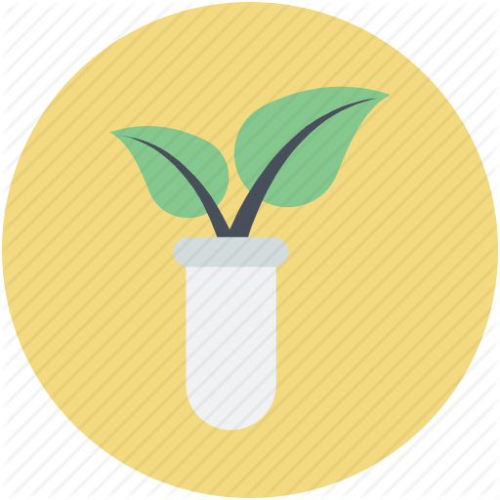
Botany: The study of plant life – agriculture, agronomy, horticulture, forestry, plant taxonomy, plant physiology, plant pathology, plant genetics, hydroponics, algae, etc.

Chemistry: The study of the nature & composition of matter, and the laws governing it – physical chemistry, organic chemistry, inorganic chemistry, materials, plastics, fuels, pesticides, metallurgy, soil chemistry, etc.
You may test some consumer products here.

CATEGORY DESCRIPTIONS (cont.)

Earth, Space & Environmental Sciences:
(Earth Science) The Study of Earth’s structure and processes. - geology, mineralogy, physical oceanography, meteorology, seismology, geography, topography.
(Space Science) – astronomy, star visibility, astrological computations
You can’t test planets, star, or the moon – no solar systems please.
(Environmental Science) – The study of interactions among physical, chemical, and biological components of the environment – air, water, and land pollution sources and their control, ecology, waste disposal, impact studies, etc.

Engineering: Technology projects that directly apply scientific principles to manufacturing and practical uses – civil, mechanical, aeronautical, chemical, electrical, photographic, sound, automotive, marine, heating and refrigeration, transportation, etc.

Math and Computer Science: Probability, statistics, applied math and analysis, artificial intelligence, algorithms, databases, programming languages, operating systems, networking, computer graphics, etc.
Medicine and Health*: The study of diseases and health of humans and animals – medicine, dentistry, pharmacology, pathology, veterinary medicine, nutrition, sanitations, pediatrics, allergies, speech and hearing, etc.

Physics: The study of matter, energy, and forces – states of matter, thermal energy, chemical energy, radiant energy, electricity, sound waves, light waves, conductors, insulators, gravity, magnetism, forces, simple machines, friction, etc.
*BE CAREFUL: When working with humans or animals you must get PRIOR approval from your teacher.
NO HUMANS OR ANIMALS MAY BE HURT DURING THE PROJECT!

Use this Progression Plan to help you stay on track with your project.
PHASE | DESCRIPTION | COMPLETE
Generating Ideas | - Complete Parent/Guardian Acknowledgement Form  - Brainstorm possible subjects or categories.  - Write investigation questions for each topic.  - Chose a topic and question that interests you.  - Form a hypothesis.  - Start recording ideas in data notebook.
Planning and Researching | - Complete Student Documentation Form  - Research the hypothesis.  - Find reliable sources of information from the internet, books, encyclopedias, media, and professionals in the field of study.  - Record research information in the data notebook.  - Compile information for a bibliography if required.  (see Bibliography Worksheet)  - Plan an experiment to test the hypothesis. (How will you test your hypothesis to find if it is valid? Where will you conduct your experiment? What will be your controls and variables?)  - Write out your procedures.  - Obtain needed supplies.
Collecting and Organizing | - Set up experiment. Safety first!!  - Make data tables.  - Conduct at least three trials (validity) and record data (measurements & observations) in tables in your data notebook.  - Record any on-going observations, and thoughts after the experiments are complete.
Analysis | - Write overall results in data notebook.  - Create graphs, charts, and visuals to help explain your results.
Communication | - Finalize notebook  - Compile and type a report (see requirements for grade level)  - Create display board (see requirements for grade level)  - Prepare a visual display using props, multimedia, etc. (optional)  - Prepare a short oral presentation of your project
Submission & Presentation | Turn in and present your project  (See requirements per grade level)
Competition | School Fair: Date and information TBA  Regional Fair: Thursday, January 23, 2020
DATA NOTEBOOK GUIDELINES
A data notebook is mandatory for all grades (4th through 8th).

When you do an experiment, you make observations. You may record changes in your subjects, make notes about possible influences in your experiment that you didn’t anticipate, or draw pictures of results along the way. All scientists are constantly recording relevant observations. Graphs, charts or tables should represent the data properly (preferably with metric units if applicable). A data notebook is a journal that may be set up to reflect observations by the week, day, hour or minute, depending on the type of experiment. You could organize it by putting a day’s observation on each page. A student’s data notebook should also contain any other notes he/she may have made from the research, such as article summaries, important phone numbers or even possible contacts. Entries should be neat, dated, and orderly. Data notebooks maybe handwritten or typed. It should be a complete and accurate record of the student’s project from start to finish. The data notebook is both qualitative (observations with senses) and quantitative (numbers & measurements). It shows all the time and effort that went into the project.
Suggestions: ½ inch binder, composition book, spiral notebook, or folder.
Day 3
January 22nd
I measured the plant growth of all three plants.
#1 = 1cm
#2 = 1cm
#3 = 1.5cm

Day 2
January 21st
My dad said to spray the plants with an equal amount of bug spray. I will have to add this control to my list.
Day 1
January 20th
Subject 1: I notice that there are some holes on my leaves. I think bugs have gotten into the experiment
Day 2
January 21st
My dad said to spray the plants with an equal amount of bug spray. I will have to add this control to my list.

REPORT GUIDELINES

A typed report is not required for 4th or 5th grade students. However, some components needed for the display board are described in the report section.
A typed report is mandatory for all middle school students (grades 6 through 8).

The typed report is a formal presentation of the research, investigation, experimentation, and conclusions. It gives detailed information about the science project, and scientific methods. It may include pictures, diagrams and added knowledge the student has gained through reading or research, experimentation, or interviews.

The entire report should be typed (12-14 font), easy-to-read, double-spaced, and placed 3-ring binder or folder. The cover should state the project title and a graphic. It should not include the student’s name. Components of the report must be neat and in order.

REPORT COMPONENTS

ALL of the following components must be included in the report and follow the same order. Those components marked with an asterisk (*) must also appear on the display board.
Title Page: Students need to have a title that reflects their science project. This is not the problem. Type only the project title; Center the project title. Do not type student name or any other information on this page. Students should include graphics, clip art, or pictures.
*Abstract: A summary of the project in a brief paragraph form. This is a one page, 250-word maximum summary of the entire project that includes the components below. It is one of the last items done. Judges and the public should have a fairly accurate idea of the project after reading the abstract. It should only include procedures done by the student. Work done by someone else (scientist) must not be included.
Abstract Components (in paragraph form)

1. Problem: The question telling what the student is trying to find out.
2. Purpose: The statement that explains why the student is doing the experiment.
3. Hypothesis: An explanation of what prompted the student’s research, and what the student thinks the outcome might be (before doing the experiment).
4. Procedures: A brief summary of how the experiment was performed.
5. Results: A brief description of the important results that lead directly to the student’s conclusion.
6. Conclusions: A brief summary of why you believe the experiment had those results and if your hypothesis was supported or not.
7. Applications: A brief summary of how you think your results can be used by others.

REPORT COMPONENTS (cont.)
Table of Contents: A list of where to find specific information in the student’s report. Page numbers must be included (placed behind the abstract summary).
Experimental Design (optional): This is a title page that introduces your experiment. It contains only the words “Experimental Design”

The numbered items below follow the optional “Experimental Design” page. Each item should be on separate page.
1. *Problem: The scientific question to be solved. The question the research answers. It should be an open-ended question that is answered with a statement, not yes or no.
Example: “How does the color of light affect the growth of a sunflower plant?”

2. *Purpose: The reason why the student is conducting this research and doing the experiment. What interested the student to study this topic?
Example: “I have decided to do my research and conduct my experiments on sunflower growth under different light conditions because my family has a garden and I want to find out how to grow the biggest flowers.”

3. Research: A multi-paragraph summary of all of the information the student has gathered from reliable sources before and during the experiment. Reliable sources may include: books, magazines, science journals, personal communication, internet, etc. Information must be written in the student’s own words, and unfamiliar terms defined.

4. *Hypothesis: The ‘educated guess’ that is the answer to the problem. It is statement with a reason. The experiment is designed to test this hypothesis. The hypothesis does not change even if the results are different. The format can be: “I think…; It is my opinion that…; I believe…because or based upon….(the reason)”
Example: “I believe that all sunflower plants need regular white light to grow. I base this hypothesis on the information I learned in my background research that showed me how plants convert light energy into food.”

The hypothesis may also be written as a prediction (cause and effect statement)Example: “ If I test sunflower plants exposed to different colors of light, then I predict the sunflowers that are exposed to white light will grow taller than the flowers exposed to other colors of light.

REPORT COMPONENTS (cont.)

5. Subject(s): Explain what organism, item or parameter you are testing. Any matter, living or nonliving is the subject.
Example: “The subject of my experiment is sunflower plants.”

6. *Constants: The parameters that are kept the same so that the experiment is valid. The factors that you do not change during the experiment.
Example: “The constants in my experiment are: the type of sunflower plants (same original height), type and amount of potting soil, temperature, amount of moisture, and amount of light exposure.”

7. *Variable(s): The item(s) that change during the experiment that are being tested.
The manipulated (independent) variable is the factor that you are testing. The responding (dependent) variable is what is measured as a response. (Both terms will be accepted- manipulated/independent; responding/dependent)
Example: “The manipulated variable in my experiment is the color of light and the responding variable is the height of the plant in centimeters.”

8. *Materials: A bulleted list of any supplies necessary to complete your study of the problem and testing of your hypothesis. Be sure to include the measurement and quantity of items listed.

9. *Procedures: A step-by-step process used to carry out the experiment. It should be detailed so that someone would be able to repeat the experiment. Use numbers to list steps beginning with a verb (like in a recipe). Do not use pronouns and informal language. The experiment must be done at least three times to increase the validity of your results. It is highly recommended to use the metric system!
Example: 1. Measure 500mL of de-ionized water into three plastic cups
2. Time the reaction with a stopwatch with 0.1 second accuracy
3. Place each type of AA alkaline batteries into each plastic cup
4. Record results
5. Repeat steps two more times for trials two and three

REPORT COMPONENTS (cont.)

10. *Data: Graphs, tables, charts, pictures, and diagrams that represent your data in an easy- to- see format that is a good representation. It is recommended that you use metric measurements. Students must include a minimum of one.
11. *Results: A summary of what was the overall outcome of your experiment based on your data. Just give the facts not your interpretation (interpretation goes in the conclusion section).
Example: “After completing the experiment, the sunflower plants grown in the white light grew an average of 5 centimeters higher than the plants exposed to the other colors of light.”

12. *Conclusion: Write a thoroughly defined summary in paragraph format about what you discovered, and how the results compare to your hypothesis. Was your hypothesis supported or not by data collected from your experiment? How did your data collected through experimentation relate to information that you collected through research?
Example: My hypothesis was… The results did support my hypothesis. The plants exposed to white light grew taller than the plants exposed to other colors of light. My hypothesis should be accepted as valid.

*Application: A summary written in paragraph form that states how the project relates to real world problems or situations. How might your project help mankind?

Recommendations: Explain what changes you would make to improve the experimental design, or give possible extensions/follow-up research or testing that could be done.

Interview Summaries (optional – not mandatory): A paragraph that explains information learned from any personal interview(s), emails, phone calls, and other forms of communication from professionals that helped your research in any way.

Acknowledgments: Give credit to anyone who helped you during the project. This is not a list of names, but a short paragraph describing who helped you and how.

Bibliography: A Properly formatted list of all sources and reference materials used for the project. (See appendix for proper formats).

BIBLIOGRAPHY GUIDELINES

4th Grade: A bibliography is not required.
5th Grade: A bibliography of a minimum of 2 sources at the end of the research summary.
Middle School: A bibliography with a minimum of 3 sources included in the report.
Reference Material | How to site information
Book | Author(s). Title of Book. Place of Publication: Publisher, Year of publication
Book with corporate author | American Medical Association. Diabetes in Adults. New York: Random, 1998.
Magazine or Newspaper Article | Johnson, Dennis. “Science is Cool.” Engineering 15 Jan 1999: 44-45.
Article in Reference Database on CD-ROM | “World War II.” Encarta. CD-ROM. Seattle: Microsoft, 1999
Government Publication | United States Department of Health and Human Services. Healthy People 2010: Understanding and Improving Health. Washington: GPO, 2000
Interview that the student conducted | Presley, Elvis. Personal Interview. 1 January 2004
Sound Recording | U2. All That You Can’t Leave Behind. Interscope, 2000
Email | Author. “Title of Message (if any)” Email to the author. Date of message.
Article from a reference book | “Science”. Encyclopedia Britannica. 1999 ed.
Web site | First, Hugo. All About Science Fair Projects. 17 December 1999. Awesome Guides. 15 November 2000  http://www.awesomeguides.com/student_science_fair-project_help.htm

The following two websites provide free bibliography tools. You will need to create an account before you can use them.
www.noodletools.com and www.easybib.com

DISPLAY BOARD GUIDELINES

A standard size (36 in X 48 in./the larger one), tri-fold display board is mandatory for all competitors (grades 4 through 8) at the school, region, and state competitions. See your school requirements for non-competing students.

4th grade students: Students who compete at the school, region, and state must have a display board with all components except an ABSTRACT SUMMARY. Students may include additional photos if desired.

5th grade students: Display boards are mandatory for all competing students. The board must contain all components except an ABSTRACT SUMMARY. Students will replace this section with a multi-paragraph RESEARCH SUMMARY. The summary should be a minimum of one typed page double-spaced. A bibliography of research sources (1 page minimum) should be attached to the back of the board for students who compete.

Middle school students (Grades 6-8): Display boards are mandatory for students who compete at the school, region, and state. The board is to contain all the components including an ABSTRACT SUMMARY.

Board size: A standard size, tri-fold presentation board that can be purchased in an office supply, or local supermarket store. It must be free standing and sturdy. First impressions can make a difference. Be creative.

Photos: All photos must have a caption. Pictures should be of the outcome of the experiment with no faces.

Judging Criteria: The display board is judged based on grammar, creativity, the scientific method, thoroughness, and neatness. All items must be typed and placed in the correct location and order. Please don’t use staples.

DISPLAY BOARD FORMAT
All items must be typed and placed in the correct location and order with titles. Wording can be larger than 12-14 font and does not need to be double-spaced.
Student names should not be written on the front of the board.

LEFT MIDDLE RIGHT
TITLE

Data
Problem

Procedures

Materials
Results
Purpose

Variables
(kinds)
Constants

Conclusion
Hypothesis

*Photos
*Photos
Abstract or Research
Summary

Data**
(extra)
Application

4th Grade: An abstract summary or research summary is not needed. Additional photos or graphics may be added.
5th Grade: A multi-paragraph research summary replaces the abstract summary. This should be a minimum of one page double spaced. Pages will be layered with the bibliography of a mininum of 2 sources should be placed at the end of the research summary.
Middle School: All components are required including the abstract summary.
*Photos are required.
**Additional space for data if necessary
The data notebook and written report are separate from the board and will be displayed in front of the board if required.

ORAL PRESENTATION

Oral presentations are mandatory for all students (grades 4 – 8) who compete. See your school requirements for non-competing students.
The oral presentation is a short 3-5 minute oral presentation describing your project and experimental design. It is also a chance for you to answer questions and show the knowledge you have gained through research and experimentation.

Oral Presentation Tips
- It is perfectly natural to be nervous.
- Begin by introducing yourself and your project.
- Explain your project components. Refer to your board headings, or write brief notes on cards, but don’t read from them word for word.
- Use visuals, pictures, graphs, or props to help explain the details of your project.
- Explain your data and how you collected it.
- Make sure you use and pronounce the key terms mentioned in your project properly.
- Maintain eye contact.
- Speak clearly and slowly.
- Practice your presentation in front of family members, friends, or a mirror.
- When finished, ask the judge, “Do you have any questions?”
- If a judge asks you a question on something you do not know, don’t worry. Discuss what you do know.

APPENDIX
(Additional Resources & Forms)
Helpful website
GRAPHING: “Create A Graph” is a free website that helps students make graphs from data tables.
http://nces.ed.gov/nceskids/createagraph/
Below are a few screenshots from the “Create A Graph” site.
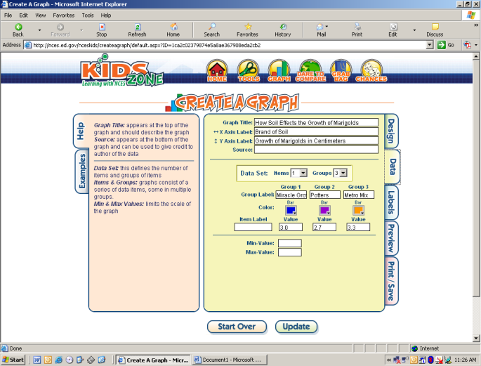
LINE GRAPH BAR GRAPH
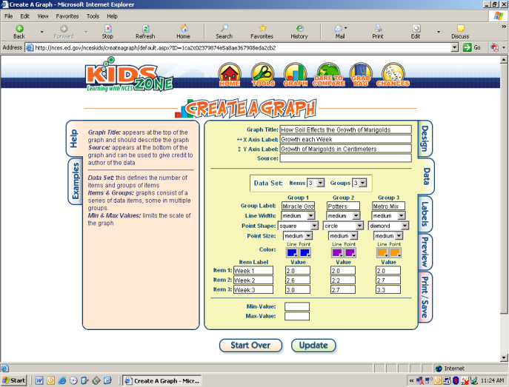

PARENT/GUARDIAN & STUDENT ACKNOWLEDGEMENT FORM

(This must be turned in to your teacher before you begin the project.)

Student Name:_______________________ Homeroom Teacher:_______________

Dear Parents/Guardians,

Please review the Imagine Schools Science Fair Student Handbook and sign this document as acknowledgement that:

- You are aware the Annual Imagine Schools Science Fair project and competition has begun.
- You are aware of the project timeline, components, due dates, and grading rubric.
- You are aware this is a long-term research and experimentation project done mostly at home.
- You are aware of the impact this project will have on your child’s grade.

- If your child wishes to compete in the school science fair, a complete project and board will be required. Incomplete projects will not be accepted.

_______________________________ ___________________
Parent/Guardian Signature Date

_______________________________ ___________________
Student Signature Date

Return to your child’s teacher by: _______________________

STUDENT DOCUMENTATION FORM
(This must be turned into your teacher and approved before you begin the project.)

STUDENT:_________________________ TEACHER:_________________ DUE: ____________

SUBJECT: (What topic do you want to research?) _________________________________________

PURPOSE: (Why you are doing the research and experiment?) ___________________________________________________________________________________

___________________________________________________________________________________

PROBLEM: (What question will you will investigate? It cannot be answered yes or no.)
___________________________________________________________________________________
____________________________________________________________________________________

HYPOTHESIS: (What you think is the answer to the question. You may change this after doing your research, but you may not change it after you begin your experiment.)
____________________________________________________________________________________
____________________________________________________________________________________

EXPERIMENT SUMMARY: (How and where will do you plan on testing your hypothesis?)
____________________________________________________________________________________
____________________________________________________________________________________
____________________________________________________________________________________

TIME NEEDED: (How long will you need to perform 3 trials?) _____________________________

MATERIALS: (What will you need to perform the experiment?)_______________________________
____________________________________________________________________________________
____________________________________________________________________________________
Expected Costs of Project: $

BIBLIOGRAPHY WORKSHEET
Use this sheet to help you gather information for your bibliography.
WEB SITE
Author(s):
Page or Article Title:
Web Site Name:
Sponsor/Publisher:
Last Revised or Publication Date: Date Viewed:
URL:
BOOK
Author(s):
Title:
City of Publication:
Publisher Name:
Year of Publication: Page Number(s):
MAGAZINE
Author(s):
Article Title:
Name of Magazine:
Publication Date: Page Number(s):
NEWSPAPER
Author (s):
Title of Article:
Newspaper:
Publication Date:
Edition: Page Number(s):
TELEVISION/RADIO
Title of Episode:
Title of Program/Series:
TV / Radio Network:
TV/ Radio Station:
Broadcast Date:
EMAIL
Mail From Name:
Title/Subject of Mail:
Mail To Name: Date Received:

