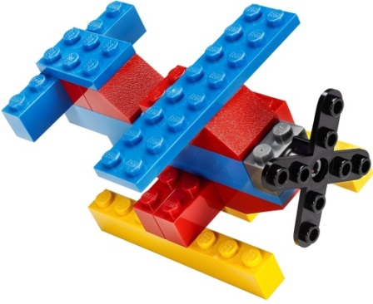
Imagine School at Town Center
Brick Builders &
STEAM Club
1st & 2nd Grade – Session 5
Discover * Design * Create
Optional Brick Builders Club t-shirt $12 each
May be worn as a spirit shirt!
_____YS ____YM _____YL _____YXL
_____S _____M ______L ______XL
Thursdays – May 2nd ,
May 9th, May 16th, May 23rd

Time: 3:30 p.m. – 4:30 p.m. Location: STEAM Lab with Ms. Demers
Fee: $20 per student for 4 sessions, to benefit the STEAM lab
Registration Form
Student’s Name: _____________________________________ Grade: ___________
How will your student get home from club? Circle One
Teacher’s Name: __________________________
Parent’s Name: ___________________________ Car Rider # ______ Aftercare
Phone Number: ______________________ Email: ____________________________
Once we have received all registration forms, we will determine if a lottery is necessary. There are only 18 slots for Brick Builders Club. Forms due 4/29/19, payment due 4/31/19. Checks please, payable to ISTC. Unpaid slots will be offered to next in line.
If necessary, we will hold lottery drawing and notify you by Tuesday 4/31/19.

I, ________________________________ give consent for my child, _______________________ to be photographed in Brick Builders & STEAM Club. Pictures are posted on www.istcscience.weebly.com.

Parent Signature: _________________________________________________
Teachers please return all registration forms to Mrs. Franklin or Ms. Demers

