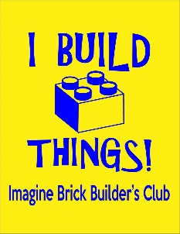 Brick Builder Club T-shirts

Student Name _______________________________ Teacher Name ___________________________
Youth XS _________ Youth SM ____________ Youth Med ____________ Youth LG ____________
Adult SM ________ Adult Med _________ Adult LG ________ Adult XL _______ Adult 2XL ________
Shirts are $12.00 each and the order placed on Thursday – 8/22/19. They can be worn on Spirit Days and to LEGOLAND. Shirts are bright yellow with blue print, shown above. Parents feel free to order one for yourself. Proceeds benefit the STEAM lab.
All orders MUST be turned in by Wednesday, August 21st

Brick Builder Club T-shirts

Student Name _______________________________ Teacher Name ___________________________
Youth XS _________ Youth SM ____________ Youth Med ____________ Youth LG ____________
Adult SM ________ Adult Med _________ Adult LG ________ Adult XL _______ Adult 2XL ________
Shirts are $12.00 each and the order placed on Thursday – 8/22/19. They can be worn on Spirit Days and to LEGOLAND. Shirts are bright yellow with blue print, shown above. Parents feel free to order one for yourself. Proceeds benefit the STEAM lab.
All orders MUST be turned in by Wednesday, August 21st

